**To solve the exercises, create a document with screenshots including the settings for each part.**

1. Create an empty virtual machine and configure the following settings:
   * For Windows 10 (64 bits, or 32 if you do not have enough RAM in your physical computer).
   * 2GB of RAM memory.
   * Boot order (CD and hard drive).
   * Two hard drives: one with 50 GB for the operating system and another one with 30 GB empty. Select the type of disk that can dynamically increase.

We click “Machine -> New”

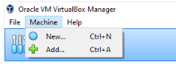

Then, we select the Operating System (OS)

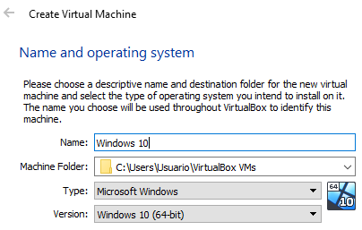

Afterwards, we can select the RAM memory we need (2 GB).

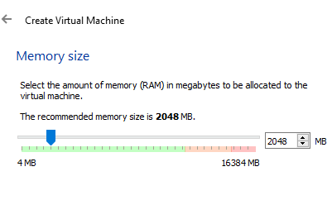

Now we create the first disk for the operating system using type VDI

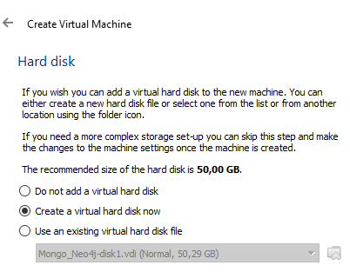

… And “dynamically allocated” in order not to waste storage

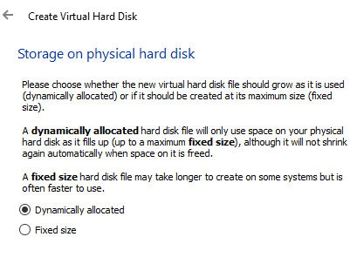

Once created the virtual machines, we can change the boot order from settings like in the screen below (clicking the “System” tab)

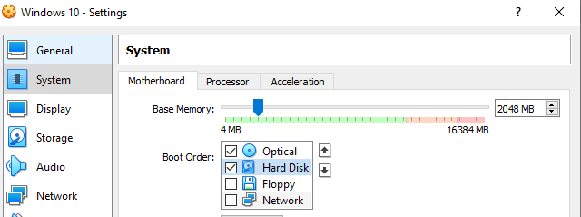

Finally, we create the additional 30 GB disk from “Storage”

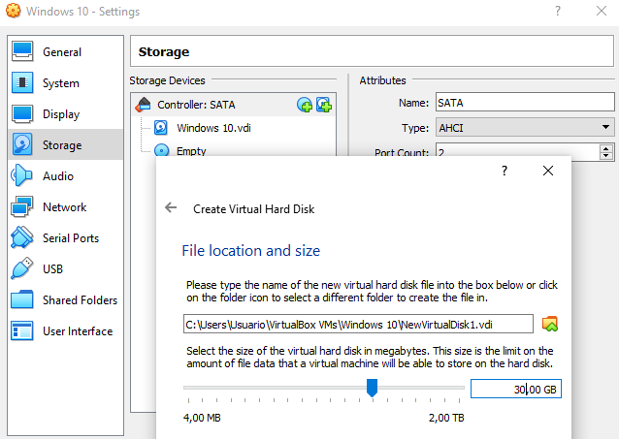

1. Install Windows 10 in the virtual machine from exercise 1. You must add the following settings:
   * USB 3.0 support.
   * Shared folders.
   * Internet connection including access to the rest of computers of the network.
   * You will be able to copy and paste from the host to the guest and vice versa.

To install Windows 10, we need to add the ISO file from the “Storage” tab

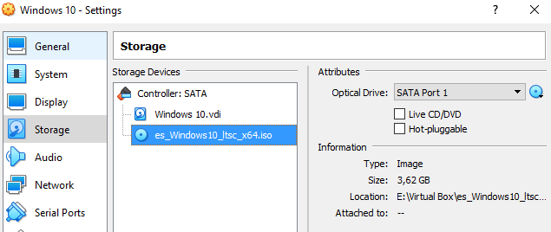

The required “Network” setting to meet the statement criteria is “Bridge adapter”

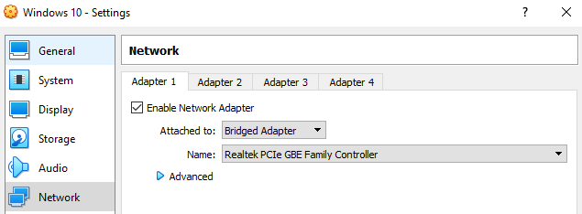

Then, we start the virtual machine and follow the steps from the files “Unit 1. Installation of free and proprietary operating systems” and “Unit 1. Summary of partitions installing Windows and Linux”. Add as many screenshots as possible regarding your installation.

Once installed Windows 10, it is necessary to setup “Guest additions” to enable the clipboard and shared folders.

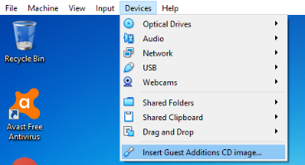

After installed, you can set these tools from the same menu as you can see the picture below, or the virtual machine settings.

For the clipboard, the correct option is “bidirectional”

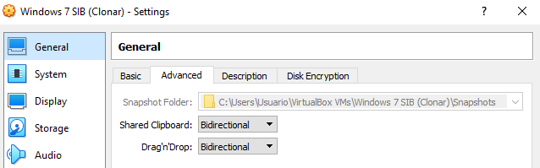

And for the shared folder, you need to select the source directory you want to use from the guest operating system. Using the “Auto-mount” you do not need to configure anything else, at least for a Windows virtual machine

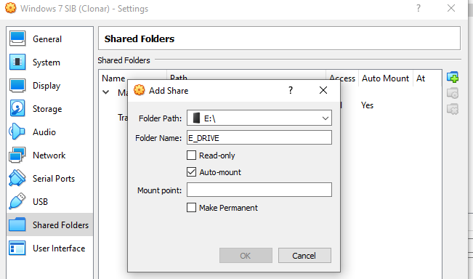

For the USB 3.0, you first need to install an extension from “File -> Preferences” in the VirtualBox main menu

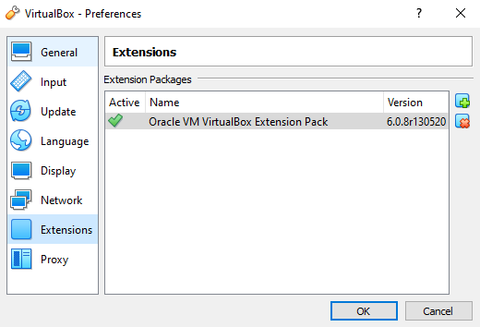

Then, you can add the required USB from the corresponding tab in the virtual machine settings

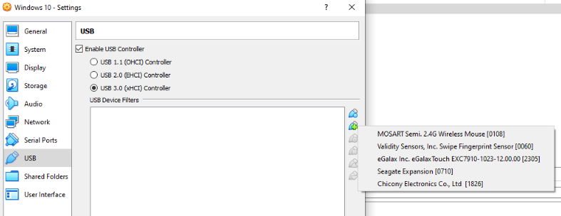

Another option is to “plug and play” when the virtual machine has been started

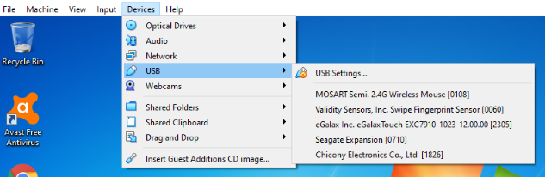

Anyway, for storage devices, it is more recommended to share a folder pointing to the external disk root folder. Using USB from VirtualBox, the device is disconnected from the physical computer and it is only possible to use it from “host or guest” at the same time. Using a shared folder, you can access simultaneously both from “host and guest”

1. Create another 64-bits virtual machine and install Ubuntu 16.04. The virtual machine must meet the following requirements:
   * 2 GB of RAM memory.
   * Just one disk of 30 GB.
   * A shared folder to an external disk.
   * Internet connection.
   * You will be able to copy and paste from the host to the guest and vice versa.

We create the virtual machine using similar settings to exercises 1 and 2, but selecting 64-bits Ubuntu

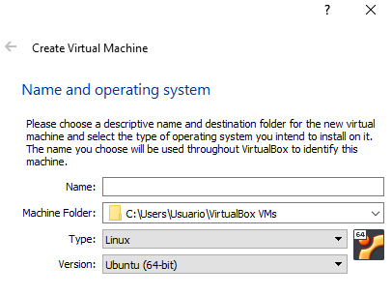

You can also follow the steps from “Unit 1. Installation of free and proprietary operating systems” and “Unit 1. Summary of partitions installing Windows and Linux”. It is especially important to set the number of partitions like in the theory. Add as many screenshots as possible regarding your installation.

We will also need “Guest additions” to enable the clipboard and share folders. Remember: from the “Devices” menu

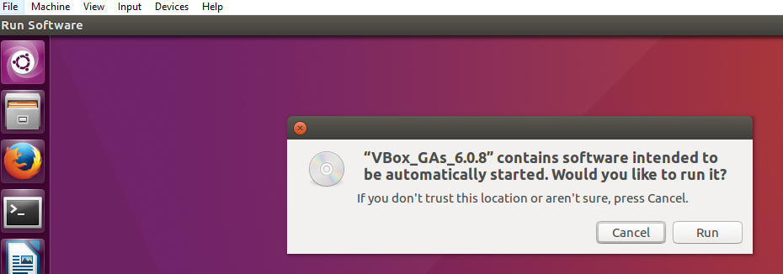

Regarding the share folder, the process is the same as in exercise 2, but you will need similar configurations like the link below.

<https://www.howtogeek.com/187703/how-to-access-folders-on-your-host-machine-from-an-ubuntu-virtual-machine-in-virtualbox/>

In this case we are only required “Internet connection”, so the default “NAT” is valid

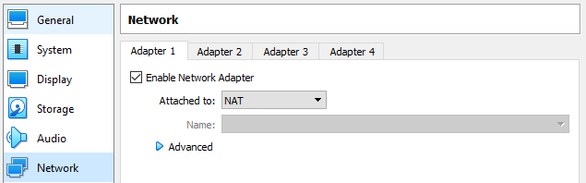

1. Create the snapshots like in the picture below using one of the virtual machines created in the previous exercises. Before each snapshot, you must change something in the operating system. This tool is normally used when performing a critical action or installing software. But, in this case, you can do something so easy as creating a new file to study the different states.

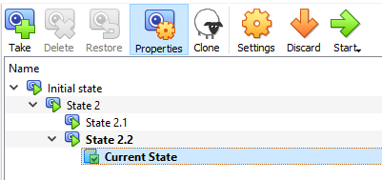

Then, complete the following actions in order:

* Restore State 2
* Delete State 2.1 and explain what happens
* Restore State 2.2
* Delete State 2.2 and explain what happens

First part: Creating snapshots. We are going to create the snapshots. For each new state, we will create a file to check the difference between snapshots.

“Initial state” -> We create a file called “File 1.txt” (or we perform a more complex action to differentiate between states). Then we take the snapshot from the “Current state”

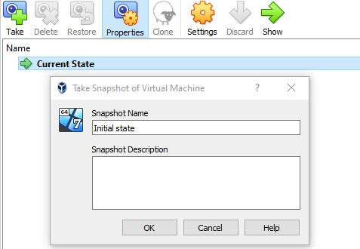

Then, from “Initial state”, we create another file called “File 2.txt” and another snapshot called “State 2”.

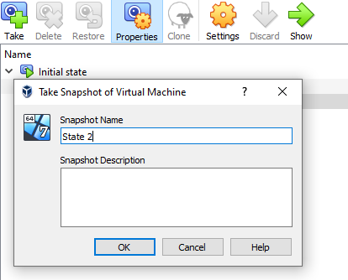

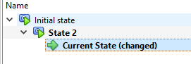

Finally, we do the same again. We create a new file called “File 2.1.txt” and another snapshot. This time the name will be “State 2.1”.

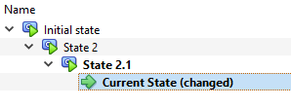

Now, shut down the virtual machine. Right-click on “State 2” and “Restore”. We can uncheck the checkbox “Create a snapshot of the current machine state” (we do not need a backup of the current state).

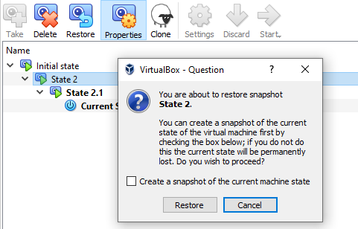

Start the machine again. You will see that there are less files like when you created the second one.

Now create a new file name, i.e., “File 2.2.txt”. At this point we have added all the required snapshots.

Second part: Restoring and deleting. We are going to restore “State 2” like in the previous snapshot.

Next, we delete “State 2.1”.

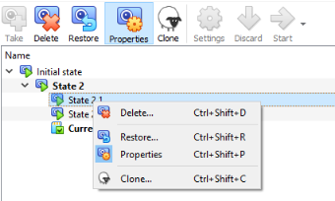

If we start the virtual machine, we will check that the file created in “State 2.1” has disappeared.

We continue restoring State 2.2

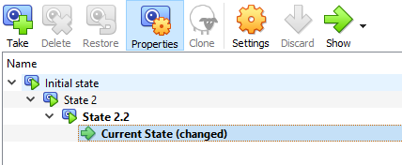

¿What happens removing State 2.2?

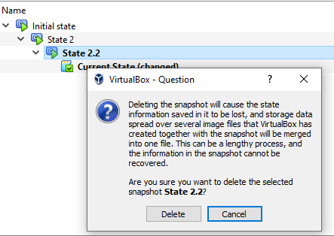

VirtualBox merges the states as much as possible. So, the file created in “State 2.2” has not been deleted.

But the snapshots are only merged if they are in the same “branch” and they depend on each other.

For example, in the picture above we can see that the “State 2” is just the previous one, so the changes are merged.

But, in the other case, we are located in “State 2” and “State 2.1” is more recent and it is not in the same “branch”, so the modifications of this snapshot are not saved.



Only for snapshots in “tree”, the states are merged like

* State 1
  + State 2 (right after State 1)
    - State 3 (right after State 2)
      * State 4 (right after State 3)